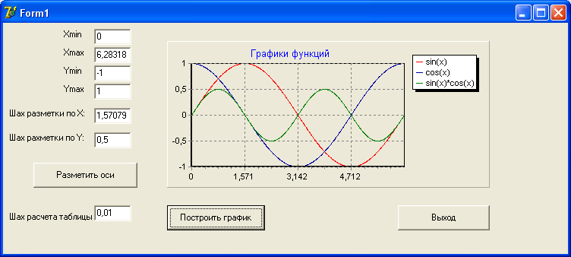
unit Unit1;
interface
uses
Windows, Messages, SysUtils, Variants, Classes, Graphics, Controls, Forms, Dialogs, TeEngine, Series, ExtCtrls, TeeProcs, Chart, StdCtrls;
type
TForm1 = class(TForm)
Label1: TLabel; Label2: TLabel;
Label3: TLabel; Label4: TLabel;
Label5: TLabel; Label6: TLabel; Label7: TLabel;
Edit1: TEdit; Edit2: TEdit;
Edit3: TEdit; Edit4: TEdit;
Edit5: TEdit; Edit6: TEdit;
Edit7: TEdit; Button1: TButton;
Button2: TButton; Button3: TButton;
Chart1: TChart; Series1: TLineSeries;
Series2: TLineSeries; Series3: TLineSeries;
procedure Button3Click(Sender: TObject);
procedure Button1Click(Sender: TObject);
procedure Button2Click(Sender: TObject);
procedure FormCreate(Sender: TObject);
private { Private declarations }
public { Public declarations }
end;
var Form1: TForm1; Xmin,Xmax,Ymin,Ymax,Hx,Hy,h:extended;
implementation {$R *.dfm}
procedure TForm1.FormCreate(Sender: TObject);
begin
Xmin:=0;Xmax:=2*pi;
Ymin:=-1;Ymax:=1;
Hx:=pi/2;Hy:=0.5;h:=0.01;
Edit1.Text:=floatToStr(Xmin);
Edit2.Text:=floatToStr(Xmax);
Edit3.Text:=floatToStr(Ymin);
Edit4.Text:=floatToStr(Ymax);
Edit5.Text:=floatToStr(Hx);
Edit6.Text:=floatToStr(Hy);
Edit7.Text:=floatToStr(h);
Chart1.BottomAxis.Automatic:=False;
Chart1.BottomAxis.Minimum:=Xmin;
Chart1.BottomAxis.Maximum:=Xmax;
Chart1.LeftAxis.Automatic:=False;
Chart1.LeftAxis.Minimum:=Ymin;
Chart1.LeftAxis.Maximum:=Ymax;
Chart1.BottomAxis.Increment:=Hx;
Chart1.LeftAxis.Increment:=Hy;
end;

procedure TForm1.Button1Click(Sender: TObject);
begin
{чтение данных из окон однострочных редакторов}
Xmin:=StrToFloat(Edit1.Text);Xmax:=StrToFloat(Edit2.Text);
Ymin:=StrToFloat(Edit3.Text);Hx:=StrToFloat(Edit5.Text);
Hy:=StrToFloat(Edit6.Text);
Chart1.bottomAxis.Minimum:=Xmin;
Chart1.bottomAxis.Maximum:=Xmax;
Chart1.LeftAxis.Minimum:=Ymin;Chart1.LeftAxis.Maximum:=Ymax;
Chart1.bottomAxis.Increment:=Hx;Chart1.LeftAxis.Increment:=Hy;
end;

procedure TForm1.Button2Click(Sender: TObject);
var x,y1,y2,y3:extended;
begin
Series1.Clear;
Series2.Clear;
Xmin:=StrToFloat(Edit1.Text);
Xmax:=StrToFloat(Edit2.Text);
h:=strToFloat(Edit7.Text);
x:=Xmin;
repeat
y1:=sin(x);
Series1.AddXY(x,y1,'',clTeeColor);
y2:=cos(x);
Series2.AddXY(x,y2,'',clTeeColor);
x:=x+h;
y3:=sin(x)*cos(x);
Series3.AddXY(x,y3,'',clTeeColor);
x:=x+h;
Until (x>Xmax);
end;

procedure TForm1.Button3Click(Sender: TObject);
begin
close;
end;

end.

